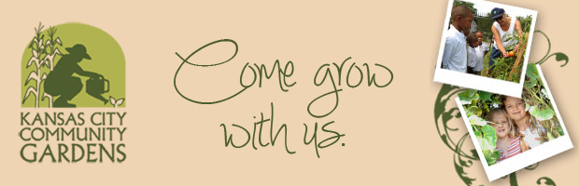
The BEANSTALK Children's Garden Girl Scout Schedule Summer 2018
The Beanstalk Children's Garden, located at our Swope Park Community Garden at 6917 Kensington, is a unique and fun field trip destination for children of all ages.
Badge Workshops

Daisies – Outdoor Art Maker Badge – Finding Art in All Aspects of Nature
June 2, 2018 10:00 – 12:00
Use all your senses as you explore our garden, making note of all the colors you see and sounds you hear! Then, try your hand at painting a landscape of your favorite plants, creating a maraca with recycled and natural materials, and learning the basics of Leave No Trace.
Brownies – Bugs Badge – Observing Insect Habitats
August 18, 2018 10:00 – 12:00
September 29, 2018 10:00 – 12:00
Bugs: find out how we can't live without them. Look for bugs in their garden habitats. Learn how to use a field guide to identify insects. Sort out "good" bugs and "bad" bugs for gardeners.
Take your Bug Craft home and share your bug expertise.

Brownies – Snack Badge - Snacks from the Garden
June 2, 2018 10:00 – 12:00
Get your snacks fresh from the garden instead of the corner store. Check out the plants in the gardens for sunflower seeds, popcorn, raspberries, and mini tomatoes Create a snack sampler and learn how to prepare a healthy garden recipe. Plan with friends what you will plant for a harvest snack party.

Juniors – Gardener Badge – Creating their Own Garden Design
May 26, 2018 10:00 – 12:00
August 25, 2018 10:00 – 12:00
Walk through the gardens full of flowers, herbs, and veggies then get started designing your own garden. It can be a large container or your whole backyard. Learn how sunlight, water, soil, and space, as well as experience and cost are essential to good garden designs.
Juniors – Flowers Badge – Creating a Neighborhood Flower Guide
July 21, 2018 10:00 – 12:00
Flowers bring beauty, joy, perfume, medicine, seeds and good nutrition to our lives. Observe the many different flowers in the fruit, herb, grain, vegetable, curiosity, and water gardens. Become a flower expert making your own personal Neighborhood Flower Guide.

Cadettes – Naturalist – Trees
June 16, 2018 10:00 – 12:00
Come relax in the shade of our many fruit trees. After learning all about trees and what they can provide for us, use your detective skills to identify which tree is which by their leaves. It’s harder than you’d think! Finish the day by designing your own tree house and tree garden and doing a tree craft with all-natural materials.

Cadettes – Eating for You Badge– Find Out How Healthy Habits Can Help Your Beauty Shine Through!
June 2, 2018 10:00 – 12:00
Can making healthy food choices really increase your energy? Do antioxidants and proper hydration give your skin a natural glow? Is added sugar really hiding in your favorite snacks? Find out the answers to these questions and more, while learning some new recipes and tasting an easy-to-prepare healthy snack!

There is a $3 fee for each girl and adult participant. Badge not included.
Please remember to wear tennis shoes. Sunscreen and water bottles are recommended.

