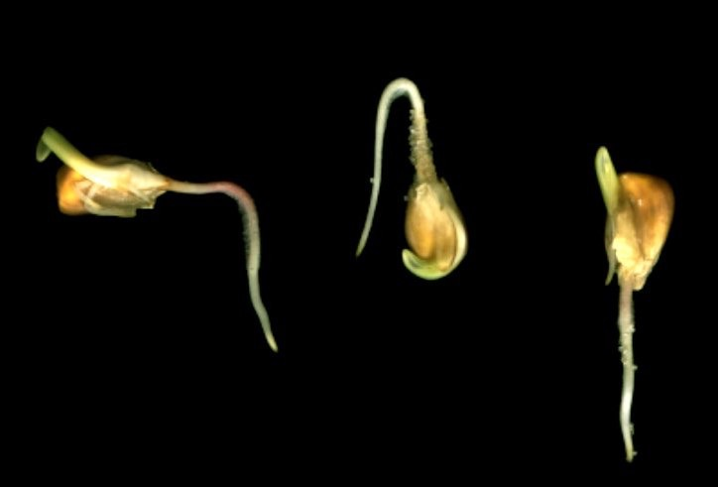
Make and Take Experiment in Cup

Purpose:
To understand how roots grow.

Seeds needed:
Beans

Equipment needed:
Clear plastic cups
Paper towels
Clear plastic wrap
Water
Re-sealable plastic bags big enough to hold the cup

Procedure:
In the Classroom:
- Dampen a paper towel and fold it in half.
- Place the damp paper towel in a cup so that it lines the sides. Place wadded up damp paper towels in the middle of the cup to hold the folded paper towel against the cup.
- Push bean seeds between the damp paper towel and the side of the cup so that the seeds rest some distance above the bottom of the cup.
- Cover cup with clear plastic wrap.
- Place in a re-sealable plastic bag.

At Home:
1. Remove the cup from the plastic bag and look at the seeds daily. Add water to the bottom of the cup if paper towels begin to dry out.
2. When seeds begin to germinate, draw a picture of how the roots are growing.
3. Five days after the seeds have germinated, carefully remove the paper towel from the cup, flip all the seeds and their roots upside down, and replace the paper towel in the cup.
4. Observe changes in the seeds and roots for another 5 days.

Answer the following questions:

- Which way were the roots of the seeds pointing just before you turned them upside-down?

- What happened to the roots after they were turned upside-down?
3. Why do roots grow down instead of up like stems and leaves?

Roots grow down by a response called gravitropism. Tropism is the turning of a plant in response to external stimulus, and gravi means gravity. Gravitropism is the way the plant turns in response to gravity. Special molecules called statoliths are in the plant roots. Gravity pulls the statoliths to the bottom of the roots. The high concentration of the statoliths in the low part of the roots causes the upper part of the roots to grow faster, thus bending the root downward. If the roots are turned another direction, the statoliths move to the new bottom and the roots bend downward again.

